Full Paper Template for ACF2026 (Title)

Wen-Cheng Liao¹, Kang Lim², and Yi-Cheng Lu^{3*}

¹ Professor, Dept. of Civil Engineering, National Taiwan University, Taipei, Taiwan
² Professional Engineer, Construction Division, Company Name, Taipei, Taiwan
³ Master Student, Dept. of Civil Engineering, National Taiwan University, Taipei, Taiwan
* Corresponding author; e-mail: acf2026.tw@gmail.com

ABSTRACT: A full paper should be prepared in the same format as follows: Use A4-size sheets. Use 14-point bold Calibri for the title. Use 12-point Times New Roman for authors’ names and affiliations. Title and authors’ names should be centered. Use 12-point Times New Roman for the corresponding author’s contact (e-mail). Insert one blank line between the affiliations and the main text. For a full paper, include an Abstract of 300–500 words. Use 11-point Times New Roman for the Abstract and the main text. Deadline for full paper submission is July 15, 2026.

Keywords: List 3 to 5 keywords here

1. HEADINGS (INDENT LIKE THIS SAMPLE IF IT IS LONG)
(1) Main heading
Capital letters in 12pt boldface fonts should be used for main headings (chapter titles) that follow the chapter numbers as shown in this example.

(2) Sub-headings for sections
The sub-headings for sections, in 11pt boldface fonts, with their initial letters capitalized, are preceded by a parenthesized section number like (2).
a) Sub-headings for sub-sections
They are written just as the sub-headings for sections are done, but follow alphabets with right parentheses. No spacing of lines is left before and after every sub-heading.

2. MATHEMATICS
Use special high-quality fonts for all mathematical equations in the text. Some equations may be placed off the text as:
$$\begin{aligned}F=ma\#\left(1\right)\end{aligned}$$
Numbered equations ((1) for example) should be center-aligned. The equation numbers in parentheses should be placed flush right.

3. FIGURES AND TABLES
(1) Location of figures and tables
Do not place Figures and Tables altogether at the end of the manuscript. Do not place any text besides figures or tables. Insert about one to two lines of spacing above the main text.

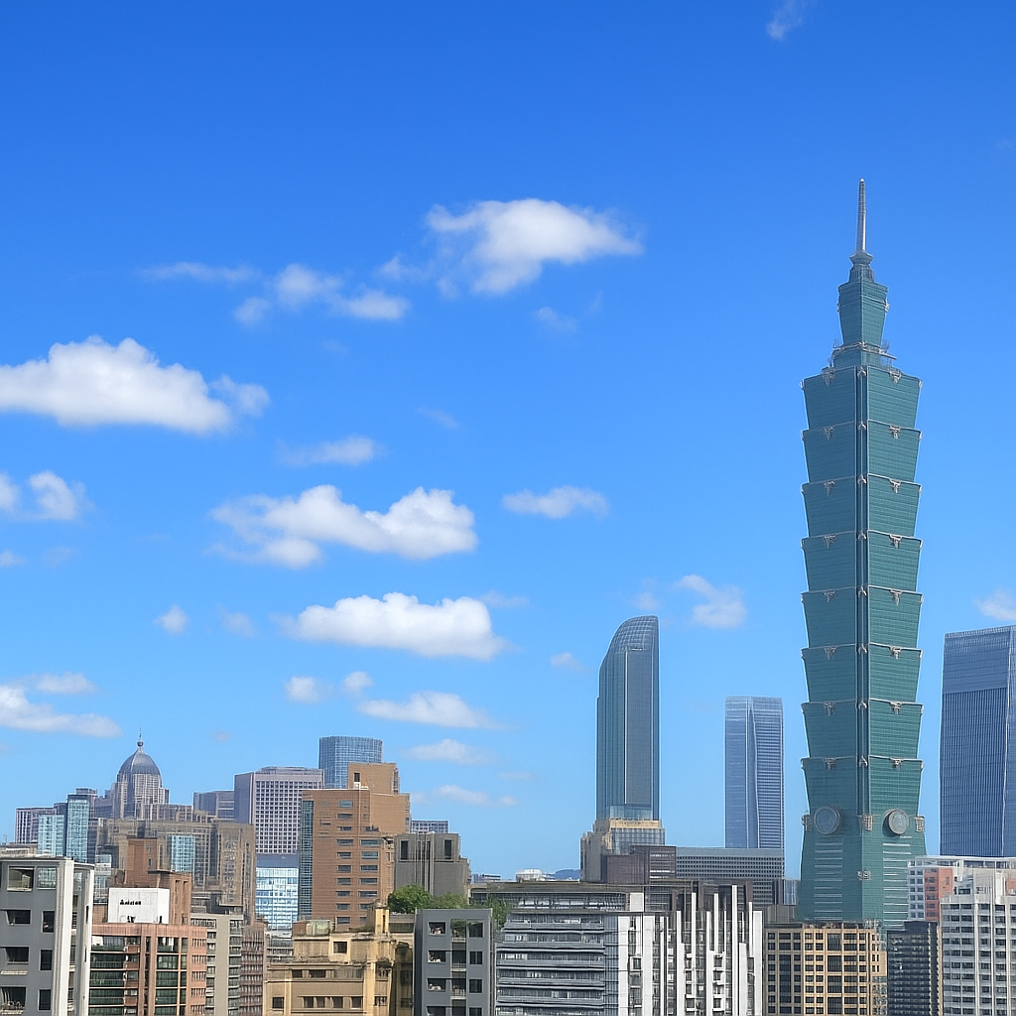
Figure 1 Taipei 101
Table 1 ACF history
No. | Year | Organized by
ACF 7th | 2016 | Hanoi, Vietnam
ACF 8th | 2018 | Fuzhou, China
ACF 10th | 2024 | Ulaanbaatar, Mongolia
ACF 11th | 2026 | Taipei, Taiwan

(2) Fonts and captions
Do not use too small characters in figures and tables. At least, the letters should be larger than those in the captions (9 pt.). Captions should be centered like an example of Figure 1 and Table 1. The heading of captions is 11pt boldface.

4. CITATION AND REFERENCE LIST
All the references must be in parentheses and used in the text (Liao et al., 2026). The reference list must be summarized at the end of the main text and sorted alphabetically.

5. CONCLUSIONS

ACKNOWLEDGMENT: Acknowledgment should follow Conclusions.
REFERENCES
References should follow APA Style
Liao, W.-C., & Hung, F.-A. (2026). Title of the paper. Title of the Journal, 12(3), 123–456. https://doi.org/xxxx

